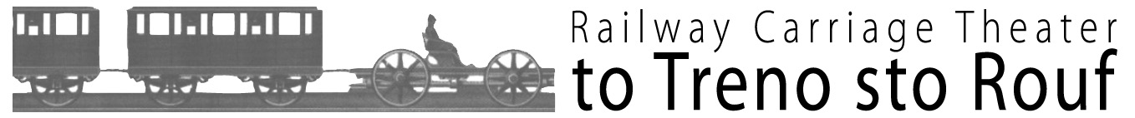
Production Office: Axana Arts Company
Tel +30 210 9237076
Fax +30 210 9240108
29, Syggrou Avenue, 117 43 Athens
theater@totrenostorouf.gr

Compartments Dance Project
A seven-day Contemporary Dance Festival

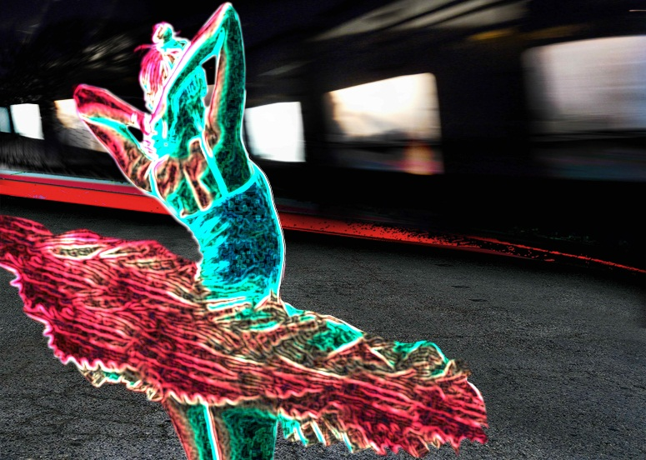
The open call for the “Compartments Dance Project” festival, a seven-day tribute to contemporary dance, released by Tatiana Ligari and the Railway Carriage Theater to Treno sto Rouf last June, was a great success; many individual choreographers and dancers or dance groups expressed their interest in creating and presenting their own short dance pieces inspired by the special ambience of the 12 compartments of the unique New Wagon venue.
From Monday the 3rd to Sunday the 9th of October 2016, 13 selected dance groups take the risk to make their special short-lived dance tour (duration between 10 and 30 min each) at the extra small compartments of the aforementioned Wagon.
The wagon’s limited space, inspiring feelings of privacy, intimacy and sharing; the coexistence of performers in close proximity to spectators/”co-travellers”; the untraditional stage form and the illusion of travel in every sense of the word (escape, departure, arrival, station, encounter, recreation, emigration, parting etc.) can become a creative challenge for both artists and audiences, turning the show into an unforgettable experience.
SHOWS
daily from Monday the 3rd to Sunday the 9th of October 2016
on a rotating 5-hour schedule from 19:00 to 00:00

FREE ADMISSION
using an access pass for up to 3 performances per day &
optional purchase of the festival’s program-poster for 1,5 €.

INFORMATION
Railway Carriage Theater to Treno sto Rouf
“Rouf” Railway Station
on Konstantinoupoleos Ave. P.C. 118 54
10’ far away from “Keramikos” Metro Station
+30 210 5298922
Free Parking / Wi-Fi

FIND US
www.totrenostorouf.gr
www.facebook.com/ToTrenoStoRoufRailwayCarriageTheatre
https://twitter.com/ToTrenoStoRouf

MEDIA SPONSORS



The dance projects

22 stops
concept, creation, performance by Katerina Drakopoulou photography and video by Ioulia Ladogianni
A distilled, sculptural, highly-imagistic, solo butoh dance piece converses with a series of photographs that trace the trajectory of a long-durational, site-specific butoh performance, which took place in the urban environment of Athens over a course of 22 days. The work attempts to capture and enhance the beauty of the mundane and invites us to re-view and re-envision shared spaces, practices, and art forms.

A journey from incomplete to whole
concept by Filio Kosmidou choreography by Filio Kosmidou and group’s improvisations performed by Eleonora Spiropoulou, Sozon Besis dramaturgical advisor Isabella Konstantinidou
Thanks to Pepi Zaharopoulou for the support
A dance project that keeps an eye on two different people on an ambiguous standby situation: waiting to leave, waiting to arrive. Being incomplete, they are seeking for their self-fulfilment as well as for the connection with themselves or with the others.

Escape journey
Wonderland Sins Dance Company – Aliki Dermati, Natalia Argiraki concept, choreography, performance by Aliki Dermati, Natalia Argiraki
"Escape Journey" is a dance duet, in which each performer reflects the destination of the other. Often the destination may coincide, other times may vary. Two different, parallel lives in a wagon cabin will easily develop a relationship. Strangers at first, gradually they come close. In their long journey, they will find out their similarities and what made them escape from their everyday routine.

Farewell
choreographed and performed by Arletta Makatsori
A dance composition, based on the poem “Farewell” by Giannis Ritsos and the movie “Parenthesis” by Takis Kanellopoulos, discussing the major existential issues of freedom, life, love and death.

In anticipation
AleaJactaEst Dance Company directed and choreographed by Vasilis Skarmoutsos performed by Christina Gazi, Vasilis Skarmoutsos costumes by Katerina Hatzopoulou assistant to the director Aris Sklavos
The dance production “In anticipation” focuses on the concept of time and its components; being in anticipation means waiting for something to happen, while the situation is directly related to time itself and its expansion. What is the role of the human body in this game?

It’s a-live
D.art Dance Group choreography, sets, costumes, performance by Vasiliki Loli, Erato Makra, Ioannis Mitsos, Danae Pappa sound design by Panagiotis Kipriotis
“It's a-live' is a dance performance dealing with reality nowadays. We are at war, communication media is selling drama and some people are sitting back and enjoying.

Leaving room
concept and choreography by Pepi Zaharopoulou performance and co-creation by Fotini Zouma, Filio Kosmidou, Leoni Xerovasila, Natasa Fouseki costumes design by Natasa Polizou costumes creation by Natasa Polizou, Sofia Skoutari
"Leaving room" is a dance project on parting, based on Neruda’s “Twenty love poems” and inspired by Natasa’s Polizou illustrations. Four movement monologues, occurring in the “leaving room”, that reach meeting points, as they progress.

Mara/Woman
Air Dance Company concept, choreography, performance by Maria Vathi, Katerina Klirodeti
"Mara/Woman” is a contemporary dance project based on the story of two women -unknown to each other- who immigrate from their homelands for different reasons and meet by fate in a train wagon. The viewer will witness that, despite their differences, it’s the same reason that brings them at the same place, at that particular moment.

The double
ina Dance Group choreographed and performed by Nicole Kafetzopoulou, Ιοulianna Banousi, Anastasia Papadaki
Three girls enter a train coach and they engage in a power play. Eventually, they put themselves in a sequel of acts which leads to the connection of their bodies thus revealing the syndrome of subjective doubles, in which a person experiences the delusion that he/she has a double.

The gaze of the other
choreography and movement supervision by Malvina-Nikoleta Androni performed by Malvina-Nikoleta Androni, Nikolas Vekrakos concept and motif by Anastasia Tsita, Marina Stergiou, Nalvina-Nikoleta Androni music supervision by Malvina-Nikoleta Androni, Nikolas Vekrakos
What could be the difference between a human body feeling observed and another one that doesn’t? This interaction as well as the construction of the public image are the project’s objects of study. The interaction with the audience is par for the course, while the small wagon’s compartments are considered as negative spaces full of possibilities.

Through the looking glass
Ohana Dance Group choreographed by Nikoleta Sofia music remixed by Katerina Haritou performed by Aggeliki Pantermali, Nikoleta Sofia music “Mood Indigo” by Duke Ellington
The dance duet is a tribute to the mirror theme. In the limited space of the wagon, the little traveller and her reflection are both trying to impose themselves on each other, they confront each other, they play together...

Trace... a human specific live performance
concept, composition, performance by Theodosia Sourelou
A dance solo on the interaction of the human body with the wagon’s limited space, creating real time human traces. The piece explores how the audience’s presence affects or even transforms space, through the performer’s body.

Vesmir in the sky
Duende Dance Group devised, choreographed and performed by Penny Alvanou, Valentini-Eleni Vekkini, Flora Karavelatzi, Evdoxia Papastamatiou
They say nothing at all, but simply stare upward into the dark sky and watch, with glowing eyes, the slow dance of the infinite stars.
Soul, space, time, infinity and universe are some of the objects of study of this short dance production by Duende Dance Company.

